|  |
| --- |
| Abbott Laboratories |
| Prognostic Health Notification for ALINITY i Vacuum Sensor |
| ALINITY i Immunoassay Analyzer |
|  |
| **R&D Quality Engineering, Version 1.0** |
| **4/26/2017** |

|  |
| --- |
|  |

Table of Contents

1. Purpose 3

2. Introduction 3

2.1 Service Assessment 3

2.2 Scope 3

2.3 Notification Profiles 3

2.4 Overview 4

2.5 Abbreviations 4

2.6 Review Meeting Minutes and Approval Status 5

3. Data 5

3.1 Source 5

3.2 Fields Needed 5

4. Alert 6

4.1 Calculation for ALINITY I Vacuum Pressure Sensor PHN Flag 6

4.2 Root Cause 6

4.3 Recommended Action 6

5. Methods and Supporting Evidence 6

5.1 Sources of Variability for the Sensor Measurements 6

5.2 Acquisition of ALINITY i Vacuum Data and Pre-Processing 7

5.3 Bias from atmospheric pressure 7

5.4 Threshold for faulty sensor detection 8

GOAL 8

Options for PHN 8

Performance 11

Appendix 1: Review Notes 12

# Purpose

To implement a Prognostic Health Notification (PHN) for ALINITY i Analyzers that will detect degrading vacuum sensor performance before the customer begins experiencing an increase in Error: 3304 ICQ System Vacuum Failure (Vacuum pressure too high).

# 2. Introduction

## 2.1 Service Assessment

Per Deborah Lemonidis of GSS, “This algorithm supports the service need  of maintaining equivalency to on market Architect PHN  alerts as this alert is in the same functional area as an Architect alert”.

## 2.2 Scope

This document describes the recommended specifications for the IA Vacuum Sensor PHN alert for the ALINITY i Analyzers.

## 2.3 Notification Profiles

|  |  |
| --- | --- |
| PHN Alert | Vacuum Sensor Alert |
| Platform | ALINITY i Immunoassay Analyzer |
| Data Source | IDAQOWNER |
| Notification | Daily Report / Instrument Serial Number |
| Analysis Frequency | Daily |
| Recommended Action | Troubleshoot 3304 System Vacuum Failure |
| IDA Table(s) Required | ICQ_VACUUMPRESSUREDATA |
| ODR Table Fields Required | MODULESN, VACUUMSTATNAME, LOGDATE_LOCAL, ADCVALUE |
| Minimum number data points required in a day to apply algorithm | 3 |
| Definition of Day | Calendar Day |
| Calculations Required | Mean ADCVALUE per day per MODULESN for the “VacuumBledOff” state data |
| Flag Criteria | If ADCVALUE Mean day/ instrument <=3549 for the “VacuumBledOff” state then Flag, else no flag. |

## 2.4 Overview



**Figure 1.** Image above taken from the Alinity ci-series Operations manual (80000071-101 2016-12-01). Note the vacuum pumps are located in the drawer identified with the number 3. The vacuum pressure sensor is located near the top of the accumulator bottle.

## 

## 2.5 Abbreviations

|  |  |
| --- | --- |
| AUC | Area Under Curve |
| BSQD1I IDA | R&D Instrument Data Analytics Database |
| CMIA | Chemiluminescent Microparticle Immunoassay |
| EDA | Exploratory Data Analysis |
| IA | Immunoassay |
| IDA | Instrument Data Analytics Database |
| PHN | Prognostic Health Notification |
| ODR | On-board Data Recorder |
| PHM | Prognostic Health Monitoring |
| psig | Pound per square inch gauge (relative to atmospheric pressure) |
| ADC | Analog to Digital Converter |

## 2.6 Review Meeting Minutes and Approval Status

|  |  |
| --- | --- |
| Review Date | Monday May 15th, 2017 |
| Participants | Scott Nixon  David Shelley  Jessica Tower (Presenter)  Hassan Al-Atat  Krista Birch  Anthony Orzechowski  Anthony Schuler  Deborah Lemonidis (Approver)  Ron Hohs  Siva Chandaluri |
| Presenter / Developer | Jessica Tower |
| Reviewer | Deborah Lemonidis |
| Meeting Minutes | See Appendix 1 |
| Action Items | NONE |
| Approval Status  (Go / No Go / On-Hold) | **GO** |

# Data

## 3.1 Source

The ALINITY i vacuum pressure data is collected during the initialization process as well as during normal assay processing. The data is sent to the ODR. The data goes from the ODR to the IDA via the AbbottLink connection and is stored in the table: icq_ VACUUMPRESSUREDATA.

## 3.2 Fields Needed

Data fields that are included in the ICQ_ VACUUMPRESSUREDATA table that are needed for this PHN include the following:

|  |  |
| --- | --- |
| Table Field Name | Definition |
| MODULESN | Instrument Serial Number Identifier |
| LOGDATE_LOCAL | Instrument Local Date and Time Stamp |
| VACUUMSTATENAME | VacuumStateName |
| ADCVALUE | AD Count (analog to digital conversion) |

# Alert

## 4.1 Calculation for ALINITY I Vacuum Pressure Sensor PHN Flag

|  |
| --- |
| Threshold |
| Mean day/ instrument <= -0.91 psig / 3549 ADC |

**Note: This algorithm was developed using Verification and Manufacturing Prototype data. It should be periodically re-visited post-launch to ensure good performance using customer data. (Model may need to be re-trained.)**

## 4.2 Root Cause

A faulty sensor will read the vacuum pressure inaccurately. This PHN will detect faulty sensors prior to the current Mode of Control specifications by using the “VacuumBledOff” state data which should provide the pressure when the no vacuum is present in the system (there is a bias to atmospheric pressure which equals approximately -0.29 psig; the vacuum is never completely bled off).

## 4.3 Recommended Action

Replace the vacuum sensor.

# Methods and Supporting Evidence

## 5.1 Sources of Variability for the Sensor Measurements

The PRSICQ001471 (SBM Mashup) provides the following sources of variation for the vacuum pressure sensor measurements:

|  |  |  |
| --- | --- | --- |
| 1 | Sensor Specifications | +/-0.26 psig |
| 2 | Resistor Tolerances | +/-0.15 psig |
| 3 | ESD Protection Leakage Current Specification | +/-0.03 psig |
| 4 | Empirical Board Noise | +/-0.05 psig |
| 5 | A/D Total Unadjusted Error Specification | +/-0.03 psig |
| 6 | AD8608 Offset Voltage Specification | +/-0.00 psig |
| 7 | AD8608 Bias Current Specification | +/-0.00 psig |

The within sensor measurement error was calculated from the collected IDA data for 55 sensors.

Measurement error = mean SD (per sensor) = 0.04 psig

This may be accounted for in the empirical board noise, but was added to the propagated error calculation as a worst case.

To determine the total error from the various sources, the square root of the summed variances should be taken by assuming these errors are independent. If the errors are just summed; the assumption is made that errors always combine in the worst possible way. This could only happen if the sources of error were perfectly correlated, (i.e.. if the two variables were not really independent). Assuming the tolerances above are 1 SD, the worst case propagated error would be 0.31psig.

$$worst case propagated error=\sqrt{{{{{0.04}^{2}+0.03}^{2}+0.05}^{2}+{0.03}^{2}+0.26}^{2}+{0.15}^{2}}$$

***Worst Case Propagated error = 0.31 psig***

Note, that if the tolerances/specifications are from a normally distributed and statistically in control process the numbers above would actually be +/-4 SD and the actual propagated error* would only be 0.09 psig. As shown below.

*\*Propagated error* = $\sqrt{{{{{0.04}^{2}+\left(\frac{0.03}{4}\right)}^{2}+\left(\frac{0.05}{4}\right)}^{2}+{\left(\frac{0.03}{4}\right)}^{2}+\left(\frac{0.26}{4}\right)}^{2}+{\left(\frac{0.15}{4}\right)}^{2}}$

Propagated error = 0.09 psig

To convert the psig values to AD Count values the following formula may be used:

$$ADCValue=3730+\left(199×psigValue\right)$$

## 5.2 Acquisition of ALINITY i Vacuum Data and Pre-Processing

A sql query of BSQD1I pulled the vacuum data for 56 Alinity I instruments from 1/2/17 to 3/13/17 which yielded 348,696 pressure measurements. Of these, 20,301 measurements were attributed to the two states where the pressure is measured with the vacuum pumps disabled. Since the purpose of this PHN is not to protect against producing a bad replicate, but to detect a faulty pressure transducer, summary statistics per day were calculated for use in the PHN. Using daily summary statistics will eliminate outliers that may be related to a special cause.

|  |  |  |  |
| --- | --- | --- | --- |
| State AND Substate | N Rows | N Categories (MODULESNDRM) | N Categories (Date[LOGDATE]) |
| MonitorBleedLevel1 UnknownVacuumSubState | 1086 | 41 | 71 |
| VacuumBledOff UnknownVacuumSubState | 1160 | 41 | 71 |

## 5.3 Bias from atmospheric pressure

The bias was calculated using the mean values per day/instrument. The average value of the mean for each instrument was calculated to be ***-0.29 psig*** (without the faulty sensor from SCM00193). This is the bias to the atmospheric pressure within the system during the “vacuum bled off” state.

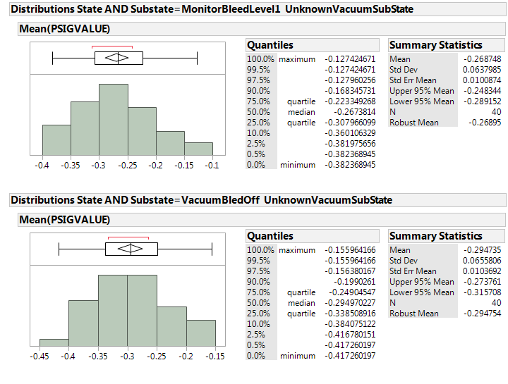

**Figure 2. Histogram and Summary stats for Monitor Bleed Level and Vacuum Bled Off Means without SCM00193 Data.**

## 5.4 Threshold for faulty sensor detection

### GOAL

The goal of this PHN is to detect a sensor issue prior to the current MOC vacuum specifications which are applied during the initialization process on a point measurement of the “monitorbleedlevel1” state.

### Options for PHN

Two options were explored 1) the threshold of the bledoff state mean/day and 2) the threshold of the bledoff state slope significance and the mean value / day over a time window. For option 2, setting a threshold based on the significance of the slope and the slope depends highly on the amount and availability of the data. Since the average number of data points for either state per day is approximately 9 and since option 1 classifies a faulty sensor from non-faulty sensors, no further work was done on using the change in pressure measurements over time. This could be revisited in the future if the PHN needs revising.

For Option 1, a lower threshold specification was determined by calculating the total allowable error. The propagated error for the sensor and the sensor measurements is shown in section 5.1 and the bias is shown in section 5.3.

To determine the specification threshold for detecting a faulty sensor, the total allowable error will be calculated as follows: TE= Bias + 2(propagated error)

*For the Monitor Bleed Level Data:*

$TE=-0.27 psig+\left(2×0.31 psig\right)$

***TE= -0.89 psig***

*For the Vacuum Bled Off Data:*

$TE=-0.29 psig+\left(2×0.31 psig\right)$

***TE= -0.91 psig***

The capability using the “MonitorBleedLevel1” data (which occurs during initialization) and the “VacuumBledOff” data (which occurs during normal running) were compared. The capability is slightly higher with the VacuumBledOff (CPK= 3.63) state data and selected for use in this PHN (MonitorBleedLevel1 CPK = 3.23). See Figure 3.

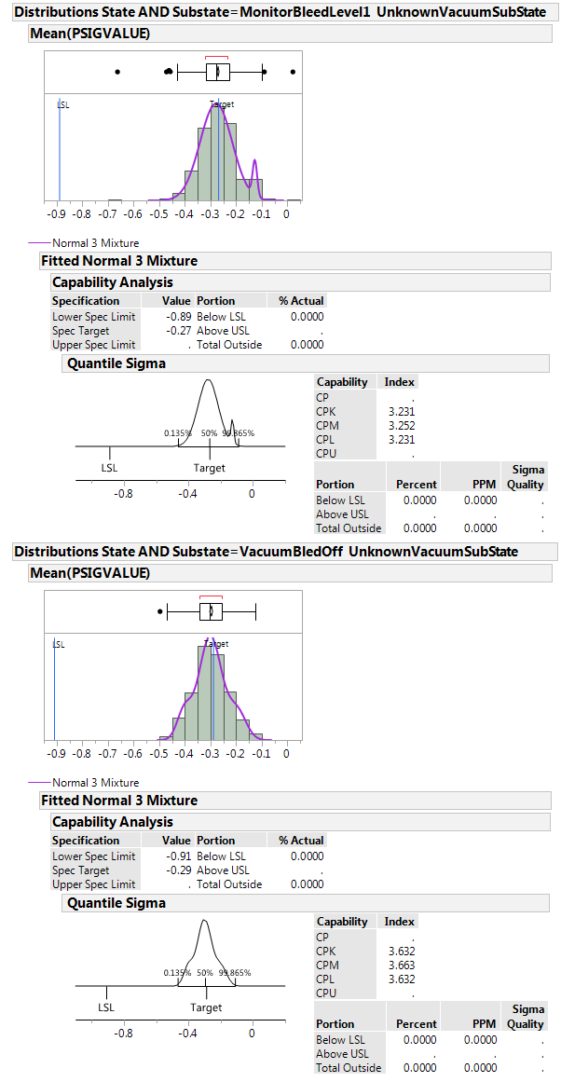

**Figure 3. Histogram and Capability for Monitor Bleed Level1 and Vacuum Bled Off Means without SCM00193 Data.**

### Performance

Only one faulty sensor has been observed in the MP and Production Instruments to date. This sensor was detected by the PHN and no other sensors were falsely flagged. Therefore, the sensitivity and specificity are both 100%.

The recommended PHN detected the faulty sensor 6 weeks prior to the first instrument error. See the figures below.

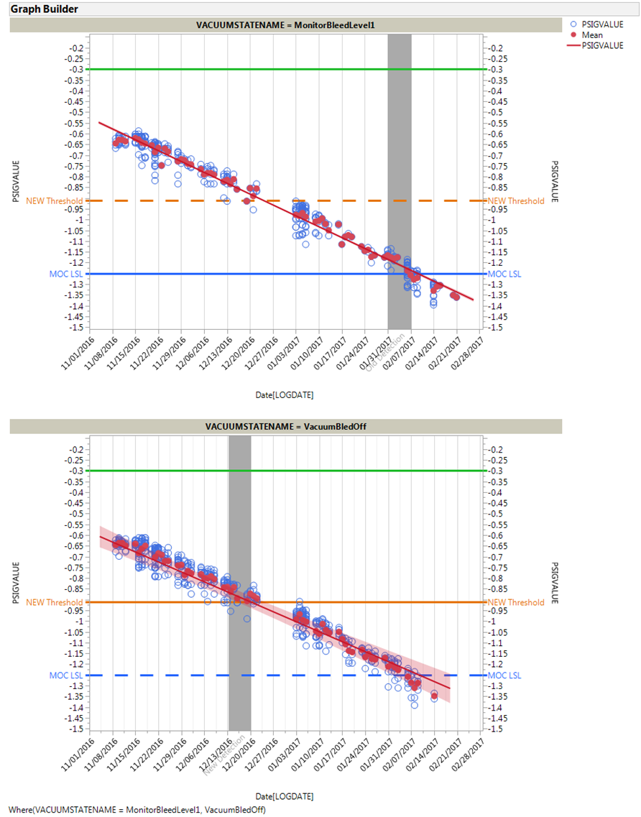

**Figure 4. Detection of SCM00193 Sensor Issue Prior to Errors from Instrument.**

# Appendix 1: Review Notes

Following meeting minutes for the Vacuum Sensor PHN Alert meeting for Alinity I:

Date: 05/15/2017, 1pm

Participants

Scott Nixon

David Shelley

Jessica Tower (Presenter)

Hassan Al-Atat

Krista Birch

Anthony Orzechowski

Anthony Schuler

Deborah Lemonidis (Approver)

Ron Hohs

Siva Chandaluri

Overview

* There is only one error that's occurred, which was not caught in a timely manner by the MOC. Similar to the FE Pressure alert, that it identifies a problem sensor.
* Two vacuum pumps, 1 vacuum sensor. A proposed vacuum sensor for the waste pump has not been implemented. Vacuum system may be redesigned in the future, but not imminently.
* Failure analysis is planned, but has not yet occurred due to limited resources. So a root cause is not yet available.
* Accounts for estimated propagated error and a bias to determine threshold
* This alert operates as a higher-value for the lower-limit threshold (higher/more conservative than current MOC).
* Where the MOC did not flag in time to intervene, the proposed limit would have flagged 6 weeks earlier (mid-December on a failure that occurred in February).

**Is this system the same as on the ARCHITECT?**

No, we do not get vacuum data for ARCHITECT, and this is a different sensor type than used for other sub-systems.

**How many failures were there: total, detected, and false-positives?**

Only 1 failure in the dataset, which was detected. No false-positives. Additional data/failures could result from failure analysis, but that’s been delayed.

There is concern due to the single failure and 6-week warning period, but this will be determined by Service as to implementation.

**Approval Status**

GO.